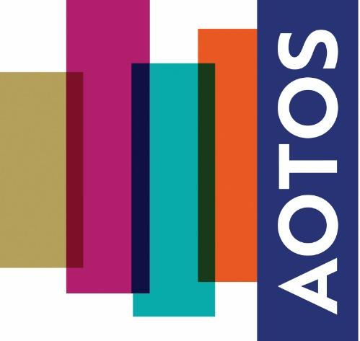

Autumn Conference 2024 – Presentation Application Form

Application Process: Please submit your abstract application to administrator@aotos.org.uk
Subject Matter: Related to the teaching and education of breathing for voice use. This may be presented theoretically and/or practically.
Abstract: 300-500 words and bibliography, submitted as a Microsoft Word Document
Deadline: 9 September 2024
Successful applicants will be informed by: 5 October 2024
Format: 15 minute Presentation/Physical Workshop (PowerPoint available)
Eligibility: Everyone, regardless of AOTOS/EVTA membership
Date: Saturday 2 November 2024
Venue: St Paul’s Girls’ School, Hammersmith.
Consent: I confirm consent of personal information completed during the application to be shared with the academic judging panel involved in the application process for this conference.

Applicant Signature:

Please format your abstract as guided below (Page 2) and return to the email address provided above by the deadline date.

- A clear title outlining your subject matter, theory, practical application, research focus, etc.
- A minimum of 300 words and maximum of 500 words summarising your presentation intention
- A clearly formatted Bibliography of any references involved in your abstract subject matter

